Rose Hasham, HBS Real-Estate SIG Lead and Head of Axe Commercial Real Estate hosts current Harvard student Joseph Hwang for a HCDExt Undergraduate Externship.

What happened? Fellow board member and Real-Estate SIG Lead Rose Hasham hosted Joseph Hwang; a current Harvard undergraduate for a shadowing opportunity in commercial real estate on January 14th as part of the HCDEXt Annual Program.
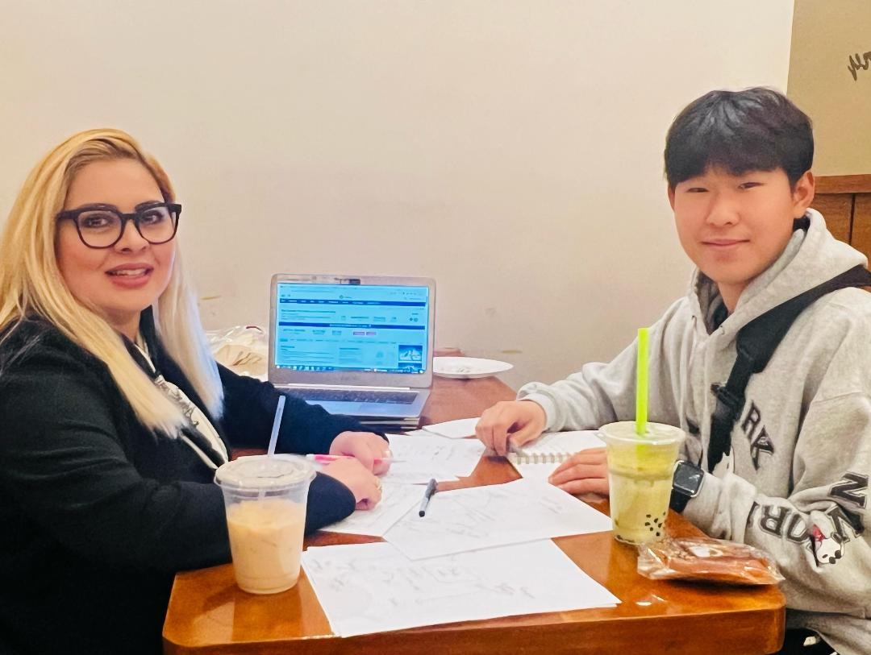
Rose who leads her own brokerage (Axe commercial real estate) based here in Dallas, TX volunteered to share a first look at the CRE industry with Joseph. Joseph started the day by first learning about the fundamentals of commercial real-estate, and the different asset classes where people invest. Rose then gave him an overview of the different career fields within CRE that exist both in public and private sectors, this was followed by the importance of underwriting assets and ending the day by touring a hospitality asset that is for sale in North Dallas.

“It is imperative that we help the next generation of young leaders learn about opportunities available to them within commercial Real estate” Rose Hasham said. “I love the knowledge transfer that happens through these programs to our future leaders and current students, it is personally very rewarding for me”.

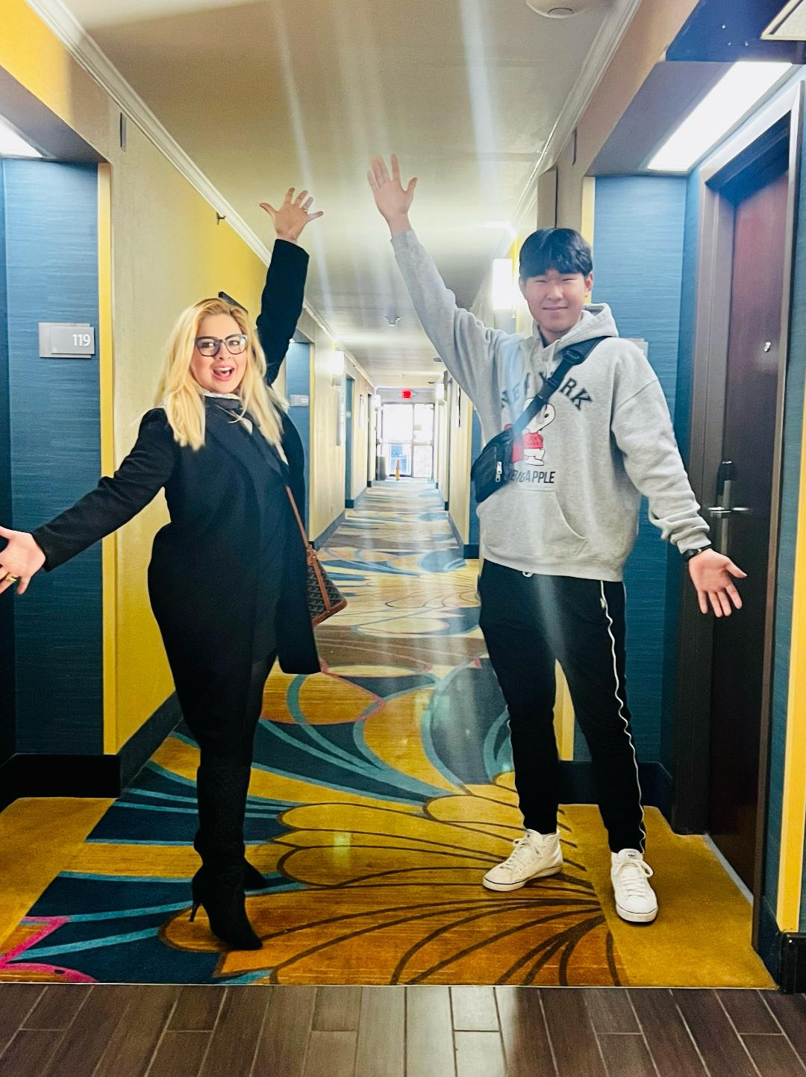
So what did Joseph think? – “This was Amazing!! Commercial Real Estate is some seriously complex stuff”, said Joseph. Joseph shared some of his key takeaways after touring a Hotel with Rose that is for sale in North Dallas:
“-The face-value of how much a property makes isn’t the whole story! There’s a lot of other expenses!
- Just because you are the owner doesn’t mean you work alone! You have a lot of people you hire and work with on managing your property!
- The right questions are important! People don’t tell you everything! You might have to do some digging and get your hands dirty!
- Commercial Real Estate has multiple avenues for jobs and careers!
- Commercial Real Estate is… EVERYWHERE!”

Overall, it was a gratifying experience both for Rose and Joseph, Joseph who is currently a freshmen at Harvard college and is planning to major in e-commerce, plans to go back at Harvard College to look up local real-estate clubs to create more connections, he is even thinking of launcing his own real-estate SIG for undergraduates on campus.

Why should you (as an alumni) care?
If you are interested in creating an externship in Jan of 2024 for your field, you can contact Shikha Sethi for further information or register at shikhasethi@harvardclubofdallas.com.

Both the Harvard Club of Dallas and The HBS Club of Dallas are committed to the professional growth and connection building of current students and alumni, leading to win-win situations for all.

What’s the externship program:
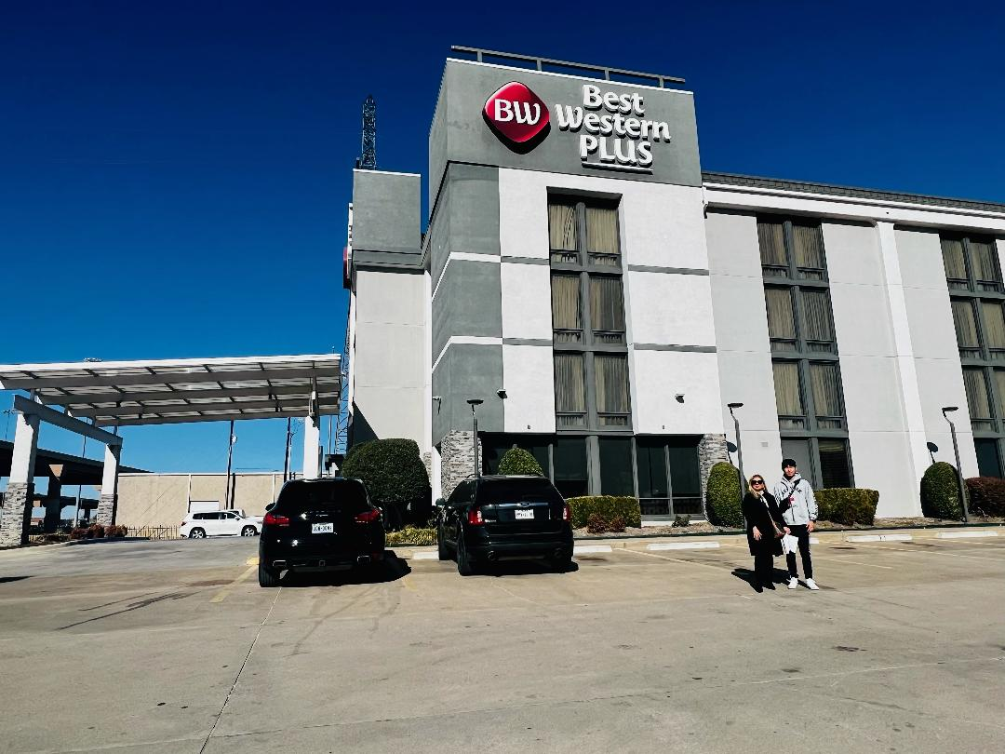
The HCDExt is an annual program of the Harvard Club of Dallas, it was offered this year between January 2- January 20, 2023. Modeled after programs offered by other top universities, HCDExt is a shadowing program offering current undergraduates a one day or two day opportunity to get a behind the scenes look at professionals and their industries.

Applications for the HCDExt January externship opened in December for all current Harvard undergraduates, and were offered in the following fields:

Marketing/Programmatic Management -Orthopedics -Investment Management/iFamily Offices -Commercial Real Estate -Product Management/Banking -PMR/Sports and Spine -NonProfit/Social Impact

